
A10
Sreenidhi Institute of Science and Technology
(An Autonomous Institution)
Code No: 101MA08/111MA08
B. TECH. II-Year I-Semester Examinations, December 2015 (Supplementary)
MATHEMATICAL METHODS FOR BIOTECHNOLOGY (BT)

Time: 3 Hours Max. Marks: 70

Note: No additional answer sheets will be provided.

Part - A
Max.Marks:20

Answer all QUESTIONS. EACH QUESTION CARRIES 2 MARKS.
- Define elementary matrix
- If the sum of the eigen values of 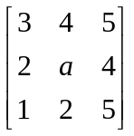 is 10, then find 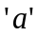
- If y = x², compute 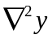
- Derive Newton’s iterative formula to find 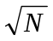
- Using Trapezoidal rule evaluate 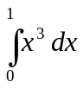
- Using Picard’s method of successive approximation obtain a solution
upto 2nd approximation of the equation 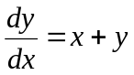 and y(0)=1
- If A = 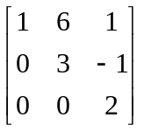 then find the eigen values of 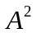.

- Find 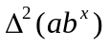
- Write the normal equations for fitting 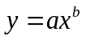by least squares method
- Give an example of a matrix of order 3 whose rank is 2

Part – B
Max.Marks:50

ANSWER ANY FIVE QUESTIONS. EACH QUESTION CARRIES 10 MARKS.
- (a) Reduce the matrix 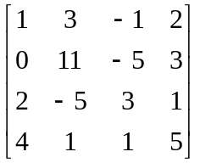 to echelon form and hence find its rank
(b) Solve the equationsby LU decomposition method

2. Verify Cayley – Hamilton theorem for 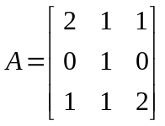 and hence find 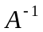.
Also find the matrix
- (a) Compute 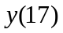using Newton’s backward difference formula, from the following table.
 | 8 | 10 | 12 | 14 | 16 | 18
 | 10 | 19 | 32.5 | 54 | 89.5 | 15.4
(b) Determine the polynomial such that 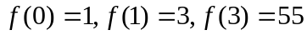 uing Lagrange’s interpolation formula. Hence find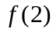
- (a) Compute the real root of x³-4x-9=0 correct to 3 decimal places by Regula Falsi method
- Using Newton Raphson method, determine a real root of the equation 3x=cosx+1
correct to 4 decimal places

- (a) Evaluate 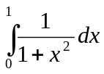 using Simpson’s th rule taking h=
(b) Fit a curve of the form 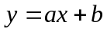 to the data given below.
 | 1990 | 2000 | 2010 | 2020
 | 0 | 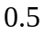 | 1 | 1.5
- (a) Solve 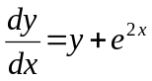, y(0) = 0 by Picard’s method and find y(0.1) (b) Solve 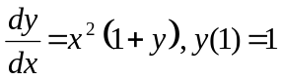 by Runge-Kutta 4th order method and find y(1.1)
- (a) Find Eigen values and Eigen vectors of the matrix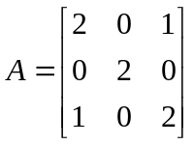
(b) Find the value of 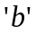 such that the system has
non trivial solutions
8. Find the values of a,b and c so that 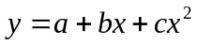 is the best fit to the data.
x | 0 | 1 | 2 | 3 | 4
y | 1 | 0 | 3 | 10 | 21
-- 00 -- 00 --

